Awareness Action Kit
- SOCIO-ECONOMIC STATUS AND SOCIAL DETERMINANTS OF HEALTH -

Global Perspectives on Inclusive Well-Being: The Role of Health and Wellness Coaching in Fostering Diversity, Equity, Inclusion, and Belonging

Empowering Individuals, Leaders, Service Providers, and Advocates of DEIB Through the Lens of Health and Wellness Coaching

- 2024 –

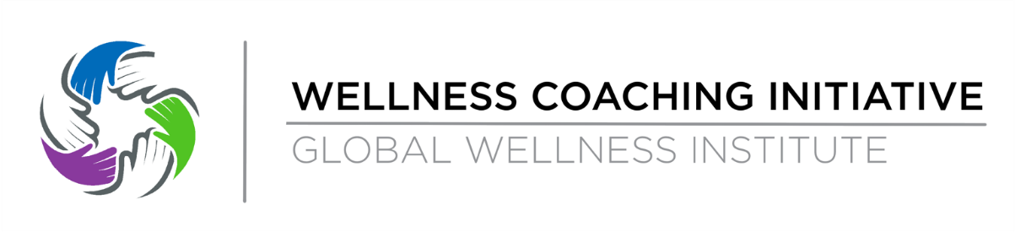

Welcome!

We are thrilled to introduce you to our Awareness Action Kit, designed to kickstart your journey into understanding the invaluable intersection of Health and Wellness with Diversity, Equity, Inclusion, and Belonging.

This kit offers you a practical, actionable, and easily digestible resource to delve into the profound impact that Health and Wellness can have in fostering a culture of Diversity, Equity, Inclusion, And Belonging.

Directly excerpted from our comprehensive 130-page whitepaper, "Global Perspectives on Inclusive Well-Being: The Role of Health and Wellness Coaching in Fostering Diversity, Equity, Inclusion, and Belonging," these resources are a simple gateway to a deeper understanding.

We invite you to download the complete whitepaper along with its accompanying PowerPoint presentation and 11-page infographic, available HERE.

Within the whitepaper, you'll explore 10 distinct areas of diversity, each accompanied by its own Awareness Action Kit:

1. Race and Ethnicity
2. Age and Generations
3. Gender
4. Sexual Orientation
5. Religion and Spirituality
6. Disability
7. Socioeconomic Status and Social Determinants of Health
8. Health Status
9. Neurodiversity
10. Weight Bias and Stigma

Each kit provides insights into the definition of the specific type of diversity, why it's crucial, how Health and Wellness Coaching can play a pivotal role in supporting it, and real-life "Voices from the field" to enrich your understanding.

Additionally, each Awareness Action Kit comes complete with a "Questions for Discussion Guide" to prompt thoughtful reflection and dialogue, as well as essential "Contact Information" to reach out for further support or inquiries. There is an (11th) separate Glossary of Terms Awareness Action Kit to enhance your comprehension across all areas covered.

Happy discovering - we're excited you’ve joined us!
The Global Wellness Institute Wellness Coaching Initiative Team.
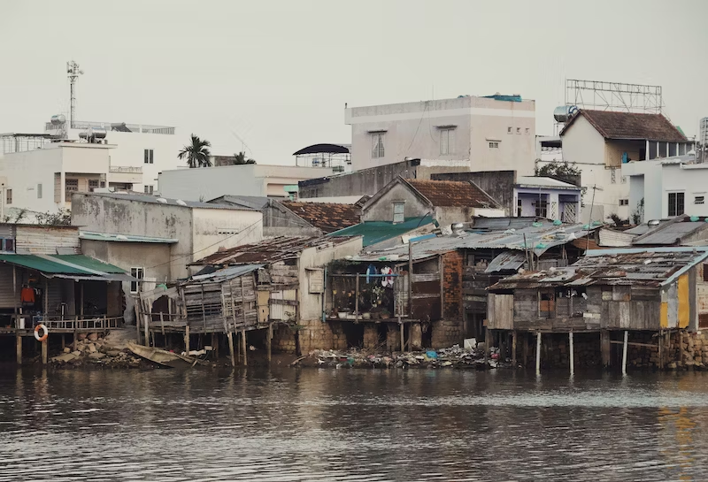

XVI. Socio-economic status and Social Determinants of Health

Socio-economic Status and Social Determinants of Health

What it is

Social determinants of health (SDOH) are the economic and social conditions that influence individual and group differences in health status (Braveman & Gottlieb, 2014). They are health-promoting (or harming) factors that reflect the conditions in which people are born, grow, work, live, and age.

The US Center for Disease Control and Prevention (CDC) defines SDOH as "life-enhancing resources, such as food supply, housing, economic and social relationships, transportation, education, and health care, whose distribution across populations effectively determines length and quality of life." (Ramirez, 2008). These include access to care and resources such as food, insurance coverage, income, housing, and transportation (Brennan et al., 2008). In Canada, the frequently used SDOH include Income and income distribution; Education; Unemployment and job security; Employment and working conditions; Early childhood development; Food insecurity; Housing; Social exclusion/inclusion; Social safety network; Health services; Aboriginal status; Gender; Race; Disability (Bryant et al., 2011).

There is growing evidence that the products and practices of some commercial actors—notably the largest transnational corporations—are responsible for escalating rates of avoidable ill health, planetary damage, and social and health inequity; these problems are increasingly referred to as the commercial determinants of health. These include the impact that key industries (tobacco, ultra-processed food, fossil fuel, and alcohol) have on health outcomes and how these intersect with health inequalities/disparities (Gilmore et al., 2023).

Why it matters

These wide sets of forces and systems that shape the conditions of daily life interfere with individual risk factors that influence the risk or vulnerability for any given health condition. Therefore, the distributions of SDOH are often shaped by public policies and cannot be detached from local prevailing political ideologies (Mikkonen & Raphael, 2010).

According to the WHO, "The social determinants can be more important than health care or lifestyle choices in influencing health. The unequal distribution of health-damaging experiences is not in any sense a 'natural' phenomenon but is the result of a toxic combination of poor social policies and unfair economic arrangements” (WHO, 2019). ‌

It is believed that the key to achieving health equity is through action on SDOH. When the WHO report was written, two major areas of SDOH were prioritized to be addressed: the first was daily living conditions and the second was the distribution of power, money, and resources, including equity in health programs, public financing of action on the social determinants, economic inequalities, resource depletion, healthy working conditions, gender equity, political empowerment, and a balance of power and prosperity of nations (WHO, 2008).

According to the WHO's Commission on Social Determinants of Health, access to health care is essential for equitable health, however, there is substantial variation in healthcare systems and coverage from country to country (WHO, 2008). Even in the wealthiest countries, there are health inequalities between the rich and the poor, the situation in poor or developing countries is much worse.

The 2011 World Conference on Social Determinants of Health, in which 125 countries participated, aimed to communicate that the social conditions in which an individual exists are key to understanding health disparities and called for new policies across the world to fight health disparities, along with global collaborations (Rio Political Declaration on Social Determinants of Health, n.d.).

How Health and Wellness Coaching can support this diversity

Health behaviors shape health and well-being in individuals and populations. A social determinants approach recognizes the interplay between the incorporation of biological and psychological processes in complex, dynamic systems, embracing a population approach that situates individuals in context (Short & Mollborn, 2015).

Health and Wellness Coaches can play a vital role in supporting clients by recognizing and addressing the impact of socioeconomic status and social determinants of health on their well-being. Firstly, coaches can foster inclusivity by creating a safe and judgment-free space where clients feel comfortable discussing the various socio-economic factors that may influence their health. This involves acknowledging that access to resources, education, and economic stability profoundly shape an individual's health journey.

Understanding the social determinants of health allows coaches to tailor their guidance to each client's unique circumstances. Coaches can work collaboratively with clients to identify realistic and sustainable wellness goals that consider the constraints and opportunities presented by their socio-economic status. This may involve adapting nutrition plans, exercise routines, and stress management techniques to align with the client's available resources and lifestyle.

Considering the commercial determinants, coaches can support clients to become more aware of the impact of industries/brands marketing alcohol, tobacco on their health choices and habits, as well as assist them to develop and implement sustainable health-creating behaviors.

Moreover, Health and Wellness Coaches can empower clients by offering education and resources that enhance their understanding of how social determinants impact health outcomes. This could involve sharing information on affordable healthy eating options, community resources, and stress reduction techniques that align with the client's socio-economic context.

Perceived susceptibility is the subjective assessment of the risk of developing a health problem (Thompson et al., 2012). The health belief model predicts that individuals who perceive that they are susceptible to a particular health problem will engage in behaviors to reduce their risk of developing the health problem. Individuals with low perceived susceptibility may deny that they are at risk for contracting a particular illness. The health belief model predicts that a higher perceived threat leads to a higher likelihood of engagement in health-promoting behaviors (Urich A., 2017). Health and Wellness Coaching adds value to a strategy for building the necessary literacy for self-care.

In addition, advocating for social justice and addressing systemic barriers is part of the coach's role. Coaches can guide clients in navigating healthcare systems, connecting them with community services, and fostering self-advocacy. By considering socio-economic status and social determinants of health, coaches contribute to a holistic and equitable approach to well-being that recognizes and addresses the broader societal factors influencing individual health journeys.

Voices from the Field

To explore what happens when coaching conversations for change and possibility are delivered to marginalized and underserved communities - that typically undergo vastly different interactions with authorities in law, healthcare, and social services - a case report describes the impact of 12 weeks of free health coaching for twelve underserved individuals. The group included homeless, formerly homeless (living on a subsidized housing complex), and low-income people, of black, Hispanic, and mixed-race origins, with almost half having recent immigrant status.

The health coaching relationships were conducted with protocols developed for managing executive health. None of the participants had ever talked with a health coach before and only three knew how to utilize low-cost public health clinics. The results show how the motivational power of coaching conversations was a promising strategy for breaking through the social isolation and loneliness of street-dwelling adults with chronic health problems. Health coaching was shown to open an opportunity for transitioning poverty-level individuals from passive recipients using public health sector services to more empowered actors with first-stage awareness who initiated preventive health actions (Jordan, M, 2013).

To address the healthcare needs of homeless veterans, the feasibility, acceptability, and utility of Peer-WHC (Wellness and Health Coaching) was evaluated, followed by pilot studies and a randomized clinical trial. Whole Health Coaching was shown to help participants make meaningful progress toward health goals, reduce stress, and improve quality of life. The emphasis on self-assessment, patient-driven goal setting, supportive, non-judgmental inquiry, and mindful awareness contributed to program success and enhanced participants’ experience (Blonigen et al., 2022; Purcell et al., 2010).

Health and Wellness Coaching has also been evaluated as a strategy for the prevention of gestational diabetes in low-income minority women. Case studies reported a range of emotional, instrumental, and health literacy-related supports offered by health coaches. This hybrid health coaching model highlights the possibility and challenge of delivering diabetes prevention program content to postpartum women in community settings (Athavale, 2016).

Contact Information

Authors, GWI WCI Members

Ellen Kocher (Chair) ekocher@whealthness.ch
Jocelyn Pepe (Vice-Chair) jocelyn@truliving.ca
Dr. M. Carolina Tuma carolina@carolinatuma.com
Izabella Natrins izabella@ukihca.com
Beth Romanski beth@myhealthytransitions.com
Shiri Ben-Arzi shiri@mci-il.com
Dr. Katrina Gisbert-Tay drkat@thecoachpartnership.com
Darrell Rogers darrell@binwellgroup.com
Fiona Cosgrove fiona@wellnesscoachingaustralia.com.au

Special thanks to our Guest Contributors
Dr. Michelle May mmay@amihungry.com
Nina Raffaele Aponte nina@bienstar.coach
Hélène Thériault Helene@functionfirstcoaching.com
Andrew Parsons andrewaparsons@gmail.com
Lauren Dixon ldixon@muih.edu
Sarah Doll-Steinberg sarah@themindpractice.com

Follow Us on LinkedIn
Wellness Coaching Initiative (Part of the Global Wellness Institute)

Want to contribute?
Health and Wellness Coaching Connection Blog Space.
It is our mission to empower individuals and businesses around the world to confidently partner with wellness coaches, optimizing health and well-being and clarifying wellness coach specialties and global guidelines through education and community resources. The GWI WCI Blog is one of these resources intended to advance the global Health & Wellness Coaching Community by providing accessible, evidence-based articles related to the field of Health & Wellness Coaching. Blogs will be posted on our area of the GWI website and cross-posted on LinkedIn.
Learn more here :
Wellness Coaching Connection Contributor Guidelines
Blog-Newsletter Submission Form
Please email us (gwiwci2023@gmail.com) if anything is unclear or if you have questions. We look forward to receiving your submissions!

Questions for Discussion Guide

Complementing our research, this Questions for Discussion Guide serves as an organized tool to facilitate ongoing discussion and contemplation on the pivotal role of Health and Wellness Coaching within the realms of Diversity, Equity, and Inclusion. Intended for educators, students, and readers, this guide provides a structured framework for further exploration, encouraging thoughtful analysis and collaborative dialogue to advance inclusive practices in the field.

- What does a diverse, equitable, and inclusive workplace/ world/ community where everyone belongs look like/feel like?

- What are the gaps in your organization around this type of diversity?

- How might you champion greater inclusion in your day to day?

- How can you champion more inclusion and awareness around this diversity?

- What might be a personal obstacle to embracing this type of diversity?

- What unconscious bias might you have in this type of diversity?
  - How might you explore your unconscious bias?

- What is the greatest challenge for you concerning this type of diversity and why?

- Who might support you to better understand this type of diversity?

- In what context might you find this type of diversity most relevant (i.e. Workplace? Schools? Community?)

- Where (country, location, venue) might this type of diversity NOT be a challenge and why?

- What has been your personal experience with this type of diversity - from the outside or inside?

